Line configuration

1. In a network, two or more nodes are connected by a communication link.
2. The communication link can be wired or wireless.
3. For visualization purposes, links are imagined as a line drawn between two points.
4. For communication to happen, two nodes must be connected to the same link at the same time.
5. This is called line configuration or connection.
6. Types:
   1. Point to point connection
      1. A point to point connection provides a dedicated link between two devices.
      2. The entire capacity of the link is reserved for transmission between those two devices.
      3. 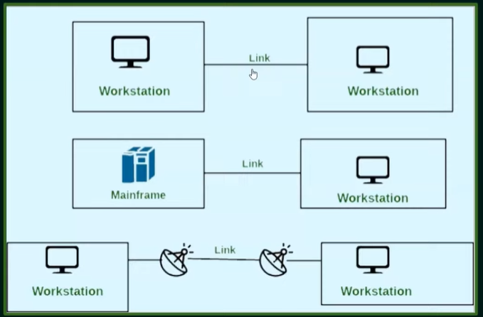
   2. Multipoint connection
      1. Also called as Multidrop configuration or broadcast connection
      2. In this connection, two or more devices share a single link.
      3. Since more than two devices share the link, the capacity of the channel is shared now.
      4. It can be spatial or temporal.
      5. Spatial: link is used by all devices simultaneously. Data can collide with each other and be unusable.
      6. Temporal: all edvices will have their own time to send the data. No collision
      7. 